Your Name
Your House Name & Number
Your address line 1
Your address line 2
Your Postcode
Their Company Name
Their address line 1
Their address line 2
Their Postcode

Date
NON NEGOTIABLE
For the Attention of: CEO [Company Name] [CEO name not essential]
Re: Reference Number: [ACCOUNT NUMBER/s]
VALIDATION OF CLAIM
Notice to agent is notice to principal, notice to principal is notice to agent
To: [CEO Name] acting in the capacity of [position in organization]
[Your Name] [Your house name or number] [Your Address line 1] [Your address line 2] [Your postcode]
I would be willing to settle any financial obligation I might lawfully owe, as soon as I have received the following lawful documentation from you. It is noted all previous payments made to your organization were made in error and without full disclosure.
I am now in possession of information of which I was previously unaware of, which suggests you may not have a valid claim to the alleged debt. Having studied the legal aspects of this alleged debt I require you to produce ALL documentation to be presented to me in SUBSTANCE and with FULL DISCLOSURE:

- Validation of the alleged debt owed with FULL accounting.
- A copy of the relevant and lawful Terms & Conditions.
- A true and certified copy (NOT photocopy) of the Deed of Assignment (NOT Notice of Assignment)
- DEED OF NOVATION: My wet signature on any agreement with your company
- A true certified copy (NOT photocopy) of the Original Credit Agreement.
- Verification of your claim against me (a sworn affidavit or even just a signed invoice)

I require a deed of assignment as mentioned above under s136 Law of Property Act 1925 – which must assign absolute title to a debt. But as there is no debt (since I created the credit), these assignments can only be assignments of agency.
During an extensive study of money and debt, and having identified your role to collect alleged sums from individuals, is it not the case, under laws of equity I am the beneficiary of the trust set up with the “creditors” signature? (Hence the need for full discloser.) It is important you give full disclosure of the lawful documents you may rely upon to validate your claim.
An agent has no standing at Law or capacity to recover a debt that has not been assigned according to Law.
I hereby give you fourteen (14) days to reply to this notice from the above date. Your failure to provide the aforementioned documentation within fourteen (14) days, from the above date to validate your claim of debt, will constitute your agreement to the following terms -
1. The debt did not exist in the first instance and/or it has already been paid in full; and that you will be held liable for any and all damages to me incurred by any further actions.
2. Remove negative remarks made to a credit reference agency forthwith, and you will no longer pursue this matter. Since case law clearly states "Unenforceable debt cannot be placed on a credit file." (Court of Appeal Grace Vs Blackhorse) doing so will potentially incur claims for damages under the DPA.
3 Since the evidence suggests you are not in possession of the require documents to substantiate any claim, you will cease and desist any and all claims from this point onwards.
4 By Accepting admission you’re not in possession of the original agreement you will disclose why this came to be.
5 Disclose who does have possession of the original agreement.
I have for your convenience enclosed a screen capture of what a judge WILL ask for at our insistence as part of pre-action protocols, and as you can see the court stamp keeps our current request within expected parameters of law.
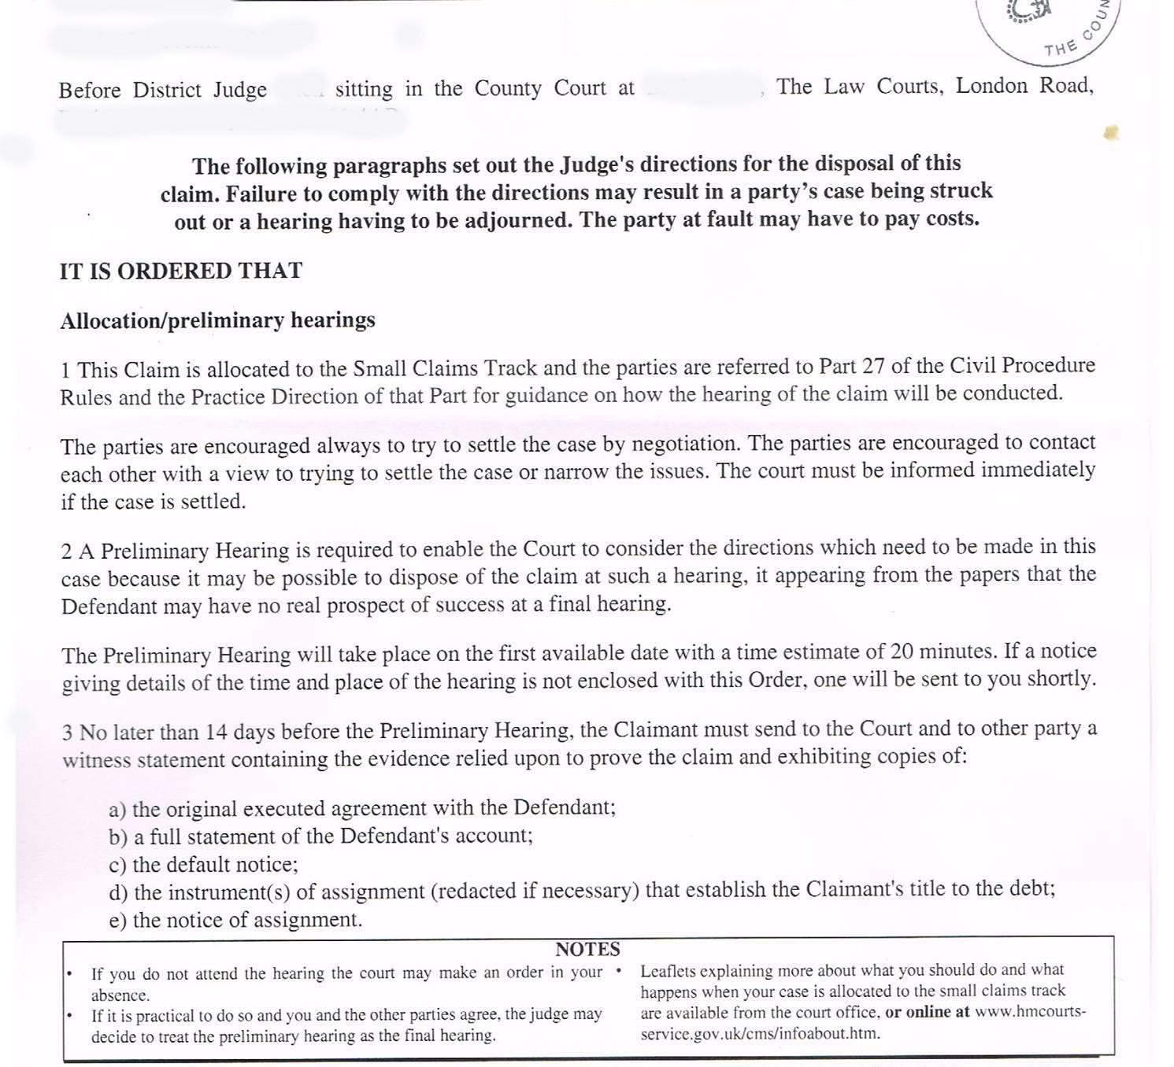
Please take note of the requirements of (a) to (e) above if you cannot provide the lawful documentation or are acting purely in the capacity of an agent (which has no standing in law) that you immediately cease and desists your invalid claims against me.
I wish to deal with this matter in writing and I do not give your organisation permission to contact me by telephone, or by any other means. Should you do so, I must warn you that the calls could constitute ‘harassment’ and I may take action under Section 1 of the Protection from Harassment Act 1997 and the Administration of Justice Act 1970 S.40, which makes it a Criminal Offence for a creditor or a creditor’s agent to make demands (for money), which are aimed at causing ‘alarm, distress or humiliation’, because of their frequency or manner.

Signed:
Authorised representative
ALL-RIGHTS-RESERVED. WITHOUT-RECOURSE. NON-ASSUMPSIT - NON ASSUMPTIVE.

